**Error Notes**

**The endpoint is wrong (try Binstitution instead of Institution)**

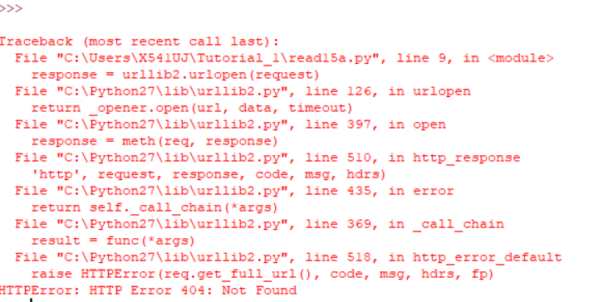

When I put Binstitution instead of institution, the http error will occur.

**The access token is wrong**

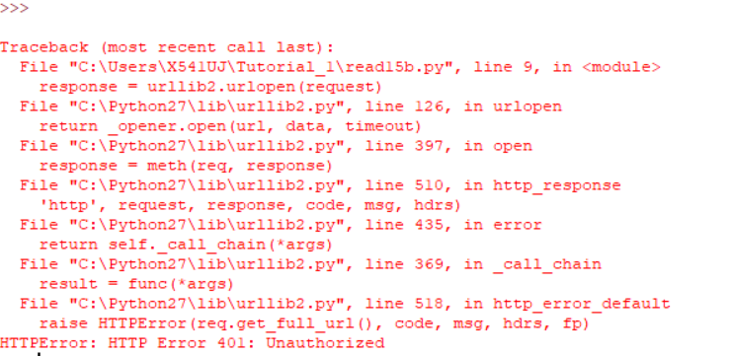

When I make wrong token, the unauthorized error 401 will occur.

**The Authorization header is not given**

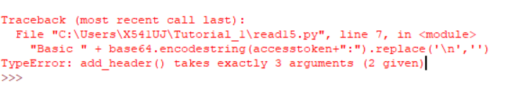

This error happened when we miss authorization header is missing